BLOGPOST - 9 Tips to Cold-Call VCs Like a Pro

9 Tips to Cold-Call VCs Like a Pro
Fundraising sucks, but it sucks even more if you don’t have connections to the investors. Here some tips to get in touch with them.

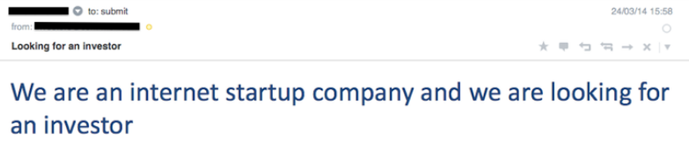
As seen in VC
#1 Do NOT cold call. Get a warm intro instead
Some stats to start with:
At Point Nine, we see around 5,000 companies per year.
But more than 50% of the investments we do come from intros through our network.
Still, around 5% of the investments we do, cold emailed us in the first contact.
There’s a reason for that, when somebody is intro’ing a company, this person already filtered the quality of the startup — which makes the life of a lazy VC easier ;-)
Since not everybody has connections into the VC world —here are some recommendations to connect, the next tips are about increasing the chances of getting a reply when cold calling/emailing.
#2 Be relevant. Not all investors invest in everything



That would have been our first investment in China…
If you are cold calling a VC, nobody will pre-filter how relevant is your company for that fund.
Therefore, you need to do some research to build a list of relevant VCs.
First, check the website of the fund. Most of them will say something along the lines of “backing disruptive entrepreneurs” — or whatever other fancy words they find for that.
That’s not enough.
To get a good understanding of their criteria, you need to understand their portfolio. Try to see if they’ve invested in similar companies — ideally, recently —in terms of:
a) Industry
You need to look at their portfolio to understand if they are more comfortable with consumer startups or they do mostly B2B, if they are patient investors or they look for quick growth, etc.
Also look for the winners and the losers in the portfolio, they will probably try to do more companies that look like the winners and they will probably stop doing companies like the losers — i.e. most VCs have an ecommerce zombie in their portfolio, or if they are old enough, a hardware company from the early 2000s ;-)
b) Stage
Most VCs will tell you they do checks from 200k up to millions. But, that’s not very relevant for you first time founder — or maybe it’s just not true ;-)
Look at the fund size, the larger the fund, the larger the initial checks they need to do.
On top of that, look at their investments in crunchbase and angellist. Did they back companies in pre-revenue phase? With some early traction? Growth stage?
c) Geography
There’s a limited number of funds who do investments cross-border — btw, that’s one of the problems of having governments as LPs…
Before shooting emails, check if they already did an investment in your home country.
As a summary, if a VC is going to do a “first-time” investment in a new geography, sector, stage, etc. it will probably happen in a company that came through an intro, not a cold-called one.
#3 Be targeted. It’s not a numbers game

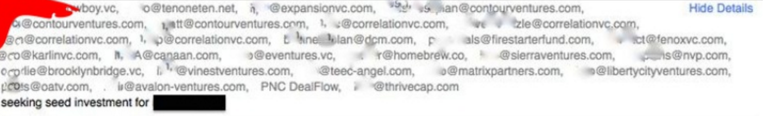
Not very exclusive :)
Now that you have a list of 10 VCs that match your startup, please don’t shoot a generic email with all of them in cc.
Try to make us feel that we discovered some hidden gem.
Write a personalized email to each of them — which, btw, also shows that you did your homework in tip #2
#4 Boost egos



Believe it or not, VC is an industry where egos are high ;-)
That’s why this feeling of finding a hidden gem is the one that you need to foster in your email/conversations.
Before writing that personalized email, check why you want to contact that specific person in that VC fund. Look at their social presence — twitter, blogs, etc. — and try to make a personal connection with them on that email — don’t over do it, we also have bs detectors :)
#5 Associates can be your best friends
Getting the attention of the super-star partner in a VC fund with a cold-call email won’t be easy — and boosting their egos might be even harder.
But most VC funds have analysts or associates who take care of pre-filtering startups.
We try to be nice people and help most entrepreneurs who are hard-workers.
If you do the effort of crafting a relevant email, the likelihood that we will reply and try to help you is a lot higher.
#6 Provide all info. Be prepared



Ask openly about conflicts of interest. Good VCs won’t risk their reputation.
That first email you are sending is the gateway to a first call.
Usually, most VCs will judge if that company is relevant for them by looking at the traction, opportunity and business model — after looking at the industry, stage and geography.
The best way to communicate that is through a great pitch.
It doesn’t hurt if you include a KPI dashboard where we see your progress on a monthly basis.
#7 Understand the process and milestones
That’s very hard to understand from the outside, but some of us are sharing how we work internally and what do we look for (1, 2, 3, 4, 5 …).
That’s a generic process within a VC fund:
Associates filter companies that sound appealing. Partners tend to send them the companies that reach out to them too. That first step is usually through email and unfortunately, most VCs don’t reply to the ones that don’t sound appealing at that stage.
After that first filtering — based on deck, email, network referral, etc. the associates take a first call with the company. Most of the time, that first call is to grab the information missing on the deck or to get a sense of the quality of the team. After that call, again, most of the companies will not pass to the next stage and they tend to receive no feedback.
For the ones that are more interesting after the call, the associate will try to push that company into the agenda of the partner and collect feedback — which might mean more calls between associate and company.
Every fund is different, so as soon as you get the chance to jump into a call and you see some interest on the other side, try to get an understanding of the process and milestones.
HINT: don’t try to skip the associates, unless you’re a superstar, pretty low chances that it will happen… and it can end backfiring.
#8 Be nice. But keep chasing.

Don’t over do it…
As you read, there’s plenty of moments where the investors “might drop the ball”.
You might think that a lack of an answer might be a no.
In most cases, you will be right, but in some others it might be that the investor is busy with something else, or it might mean that you’re interesting but still too early for the fund criteria.
Keep chasing, in a nice way, until you find out where the investors stand — that’s always fair to ask.
Also remember, NOs aren’t forever. Ask next milestones and catch up again.
#9 Explore their network. Ask for intros.
Unfortunately, doors will get closed.
But if you did a good job, you probably started building a relationship with some of those VCs.
From now on, you don’t need to cold call them anymore and what’s even better, they can probably do warm intros to some other relevant connections in their network.
With those tips, fundraising will still suck, but hopefully, at least, you will get a first reply. After that reply, then your communication, traction, market and team will define the next steps.

Aus <https://medium.com/point-nine-news/9-tips-to-cold-call-vcs-like-a-pro-ffa58f5edd8c#.5vrhtsmfw>

